Analysis Report

Problem Statement:
A SaaS company is in need of a monitoring system, one feature of the monitoring system is classification of log messages. Log messages are messages generated by the Product which describes the activities and their status. The SaaS company does get log messages, but they cannot utilize it since there is no notification of what has occurred in the product.

Our solution should be to create a Model which analyses the Log Messages and classifies what type of Message so that it can notify the right team or individual.

Scope of the report:
This report gives detail view on the dataset, the key phases like clustering, building regex classifier, and evaluating regex classifier

Data Exploration
'ModernCRM', 'AnalyticsEngine', 'ModernHR', 'BillingSystem',
'ThirdPartyAPI', 'LegacyCRM'

HTTP Status', 'Critical Error', 'Security Alert', 'Error',
'System Notification', 'Resource Usage', 'User Action',
'Workflow Error', 'Deprecation Warning'

What are we trying to classify?
log_message

We transformed each row in the log_message into embeddings.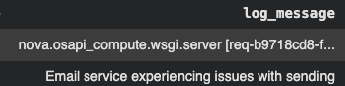
We used Sentence Transformers to create the following embeddings
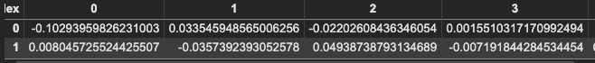

Clusters we made were not accurate due to poor configuration of the DBSCAN algorithm
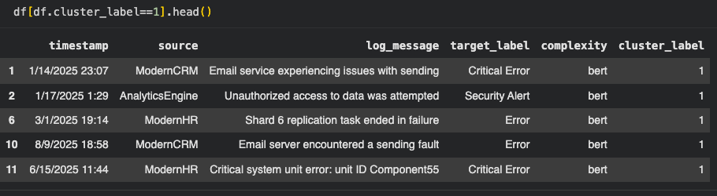

New Configurations
Eps: 0.5 -> 0.2
Min_sample : 5 -> 1
Metric : “cosine”

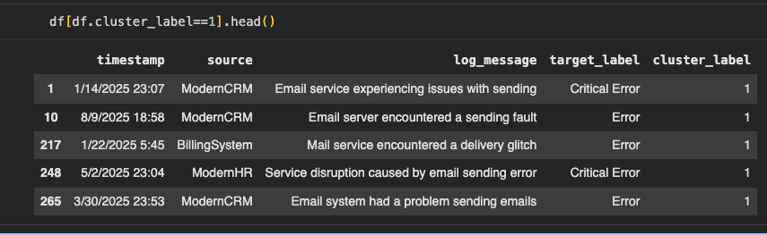

Clusters are a bit better since there are more email or mail words

Regex Classifier
Goal : The classification function takes in a single log message and returns a label.
It compares the log message with the patterns
Classification Report
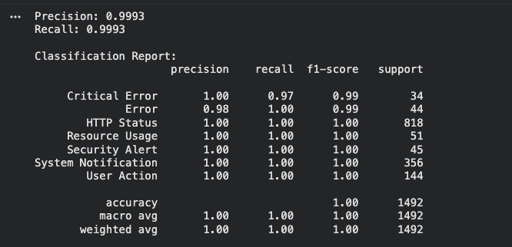

Regex Classifier Conclusions:
Total Rows: 2410

